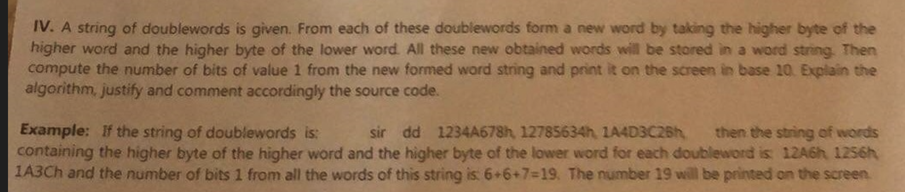

When working with strings we usually put in esi the initial string and in edi the final string

OR use esi as the index in the string

Inc esi

Ecx=the number of times the loop will be executed

Jecxz-use for safety so as not to enter an loop if ecx is 0

Lodsb/w/d store the byte/word/dd from esi into al/ax/eax

Stosb/w/d store al/ax/eax into edi

Movsb/w/d move from esi to edi

Fisierul cu functia

Multi module

Global nume_functie

Extern printf, exit

Start:

Push dword parametru

Call nume_functie

Push param

Push format

Call [printf]

Fisierul unde se apeleaza functia

Global start

%include “nume_fisier.asm”